**University Of Engineering And Technology**



**College Management System**

**Group Members:**

1. Kashif Muneer 2021-CE-34
2. Dilawar Hussain 2021-CE-51
3. Muhamd Shahzaib 2021-CE-41
4. Mehmood Ul Haq 2021-CE-35

**Submitted To*:***

Raja Muzammal Muneer



# **Introduction:**

The main objective of college management system is to automate all functionalities of a college or university. Using this system, you can manage all college management works. Using this college management system, you can view or update data and information about students and staff easily.

College management system provides the easiest way to manage all functionalities of a college. This system facilitates colleges to maintain the functionality related to college employees and their students.

**Features:**

Following are the features of college management system:

* Principal of college can add new student courses.
* Principal can delete and manage student courses.
* Admin can add new students
* Admin can update and edit student records.
* Admin can see the details of students.
* Students can view their current courses.

# **Objectives:**

1. This project will provide us with the critical knowledge of python programing.
2. This is a fully functional GUI base project developed in python that covers all of the features that an IT student needs to make a simple college management system.
3. We will become familiar to interact with Graphical interface within python
4. It will provide practical experience and understanding by working on different projects.

# **Socio-economic benefits:**

1. It provides information to the organization to management activities efficiently.
2. Students can easily know about their subjects they currently studying.
3. Principal can add new courses for students.
4. Principal can easily update the syllabus.
5. Admin can easily add new students.
6. Admin can also edit and update student information.

**Flowchart:**

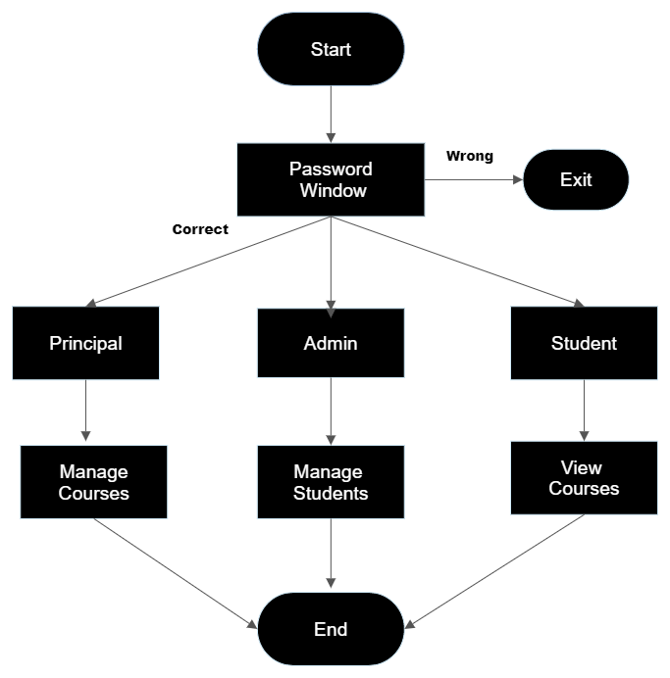**­**

# 

# **Libraries:**

A Python library is **a collection of related modules**. It contains bundles of code that can be used repeatedly in different programs. It makes Python Programming simpler and convenient for the programmer. We have used following libraries in our code:

* Tkinter
* Messagebox, Label, Button
* Random
* Sqlite3,sys
* Webbrowser

(Figure 1)

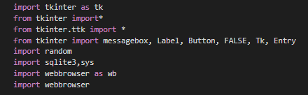

The default Python interface for the Tcl/Tk GUI toolkit is the tkinter package ("Tk interface"). The majority of Unix systems, including macOS, as well as Windows machines support Tk and tkinter.

(Figure 2)

Tk(): It controls all the other elements of the tkinter programme and aids in displaying the root window.



(Figure 3)

Your apps can show message boxes by using the tkMessageBox module. You can utilise a variety of the capabilities offered by this module to show the proper message.

Showinfo, ShowWarning, ShowError, AskQuestion,are a few of these features.

 (Figure 4)

Python Random module is an in-built module of Python which is used to generate random numbers. This module can be used to perform random actions such as generating random numbers, print random a value for a list or string, etc.

 (Figure 5)

SQLite is a C library that provides a lightweight disk-based database that doesn't require a separate server process and allows accessing the database using a nonstandard variant of the SQL query language. Some applications can use SQLite for internal data storage.

 (Figure 6)

In Python, webbrowser module is a convenient web browser controller. It provides a high-level interface that allows displaying Web-based documents to users.

# **Code Snippets Used:**

These are the code snippets that we have used frequently in our code:

(Figure 7)

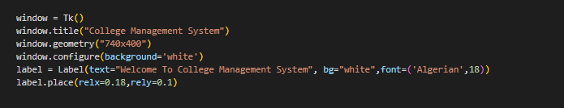

Tk(): It controls all the other elements of the tkinter programme and aids in displaying the root window.

Window is the window you create, and window.title("My Title") sets the title of that window.

Geometry(): The size, location, and other characteristics of the screen layout we're going to design are determined by the geometry funvtion, which is a fundamental technique.

Configure(): This is used to change the window color according to user specification.

Label(): This is used to display a label inside our tkinter window.

Label.place(): This is used to place a label inside our tkinter window.

(Figure 8)

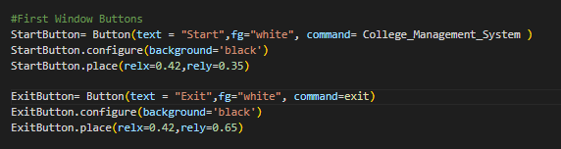Button(): This is used to create and manage buttons in tkinter widow.

Configure(): This is used to change foreground and background color button in tkinter window.

Place(): This function of this is to place button relative to x and y in tkinter window.

**Functions() in Code:**

There are five functions in our code:

1. College_Management_System() (Main Funtion)
2. Principal_Field() (Sub-Function)
3. Admin_Field() (Sub-Function)
4. Student_Field() (Sub-Function)
5. Password_Window() (Sub-Function)

**College_Management_Function():**

This function firstly destory previously opened tkinter window and then it create its tkinter window according to discussed previously in making of tkinter window and buttons in window. Each button is connected to a function as long as the button is pressed the respected function is called. The sub functions that are created in this function are given below:

* Principal_Field()
* Admin_Field()
* Student_Field()
* 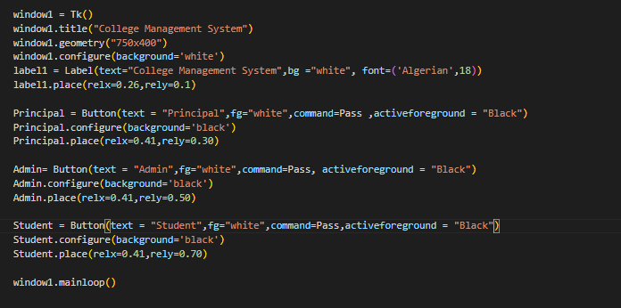Password_Window() (Figure 9)

**Principal_Field():**

Principal_Field() is a sub-function in college management function. The is password protected window. This window cannot be opened until unless someone entered correct password. When correct password is entered subfunctions is created which is used to perform different management tasks easily.

**Working:**

This is used to manage courses of students. The head of the college can easily add, delete, update courses of students of different classes depending upon the current courses. Principal can also use search online option to search something online.

**Code:**

We have made different functions in our principal function to make it convenient for the principal to add, view, delete, update courses.

**Add Book():**

The working of this function is used to add new books in the previous collection of book for this we have created dictionaries and student database.

(Figure 10)

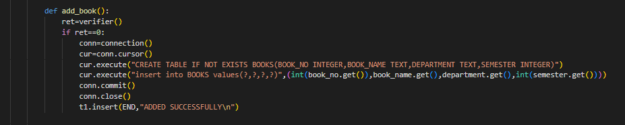**Delete Book():**

The working of this function is used to delete a previously available book from collection of book stored in student database.

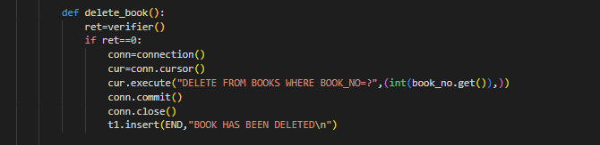

(Figure 11)

**View Book():**

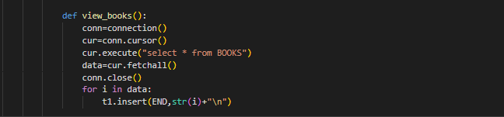The working of this function is used to view all previously available collection of book stored in student database.

(Figure 12)

**Update Book():**

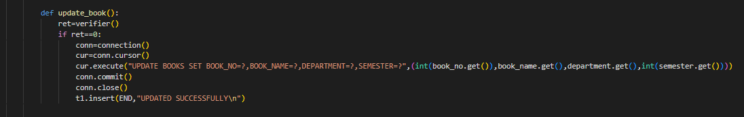The working of this function is used to update a books in the previous collection of book stored in student database.

(Figure 13)

**Admin_Field():**

This is a sub-function in college management function. The is password protected window. This window cannot be opened until unless someone entered correct password. When correct password is entered user is entered in this subfunctions

**Working:**

This working of this function is to manage student records. The admin can easily add, delete, update data and information of students.

**Code:**

We have made different functions in our admin function to make it convenient for the admin to add, view, delete, update student record.

**Add Student():**

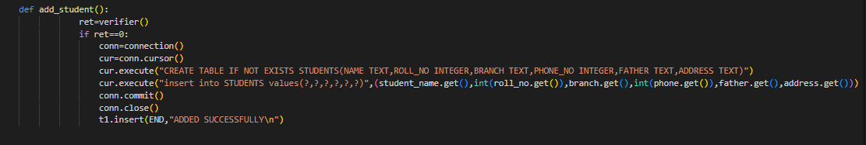 The working of this function is used to add new student information in the previous student records. For this we have created dictionaries and student database.

(Figure 14)

**Delete Student():**

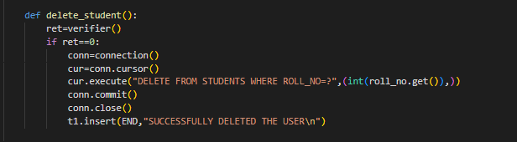The working of this function is used to delete a previously available record of student from collection of students records stored in student database.

(Figure 15)

**View Student():**

The working of this function is used to view all previously available collection of records of students stored in student database.

(Figure 16)

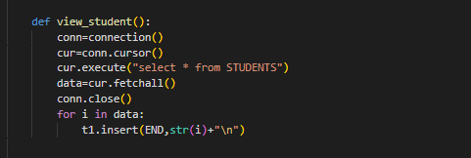

**Update Student():**

The working of this function is used to update a student record already available in the previous collection of student records stored in student database.

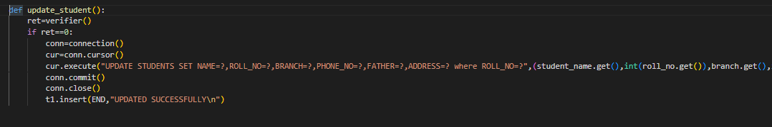

(Figure 18)

**Student_Field():**

This is also sub-function in college management function. The is password protected window. This window cannot be opened until unless someone entered correct password. When correct password is entered is entered subfunctions is created which is used to perform different management tasks easily.

**Working:**

The working of this function is to provide students facility to view the information of their class students and also students are able to view their current courses. Students only view the courses, they can’t update or change any of the information regarding to their classmates and courses.

**Code:**

We have made functions in our student function to make it convenient for the student to view current courses and information regarding to their classmates.

**View Book():**

The working of this function is used to view all previously available collection of book stored in student database.

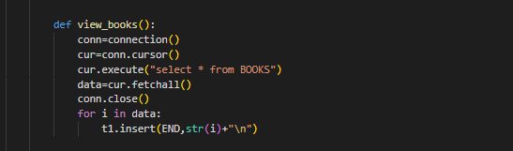

(Figure 19)

**View Student():**

The working of this function is used to view all previously available collection of records of students stored in student database.

(Figure 20)

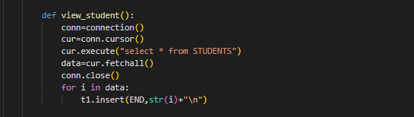**Limitations and future enhancement:**

Although this is a well-equipped Graphical user interface program but it doesn’t provide much management facilities like student attendance, student marks sheet, student result report etc. But it is efficient in use to add student records and their details. It is also useful in updating student courses and much more. Although this program lacks in different way but we assure you that in future if we end up selecting this project again we will work on our deficiencies and try to make it more efficient for our daily use.

**Tool Software:**

* Visual Studio Code (Vs Code)
* Spyder

# **References:**

DataQuest. (2022). 55 Fun (and Unique) Python Project Ideas for Beginners in 2022.

*GitHub*. (n.d.). Retrieved from https://www.github.com

Harry, C. W. (2020). Python Project For Absolute Beginners.